REPORT JULY 07

|  |  |  |  |
| --- | --- | --- | --- |
| Date: | 07 JULY 2020 | Name: | M V Ramya |
| Course: | Matlab | USN: | 4AL17EC045 |
| Topic: | Indexing into and Modifying  Arrays,Array Calculations. | Semester & Section: | 6th SEM A |
| Github  Repository: | MV-Ramya-045 |  |  |

Image of the Session

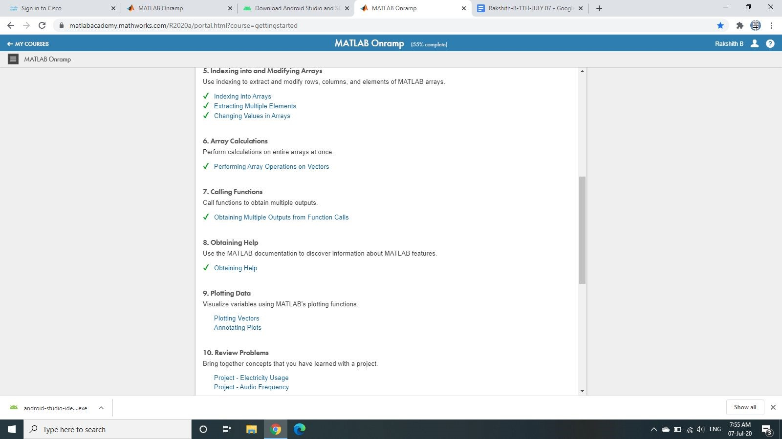

|  |
| --- |
| Report:  For long vectors, entering individual numbers is not practical. An alternative, shorthand method for creating evenly-spaced vectors is to use the : operator and specify only the start and end points.  y = 5:8 y =  5 6 7 8  Notice that square brackets are not needed when you use the colon operator. |
| The size function can be applied to an array to produce a single output variable containing the array size.  s = size(x)   |  |  | | --- | --- | | If you only need the second output from a function, you can use a tilde (~ | ) to ignore specific outputs. |   ​​     |  |  | | --- | --- | | For example, you might only want the index containing the maximum value in a vector: | density = |   ​  data(:,2)  [~,ivMax] = max(v2) densityMax = density(ivMax)     |  |  |  |  | | --- | --- | --- | --- | | Try getting the index value of the minimum value in | v2 | . Use this index to extract from | density |   ​ ​ ​ .​  The MATLAB documentation contains examples and information that can help you when working on your own problems.  Two vectors of the same length can be plotted against each other using the plot function.  plot(x,y) |

|  |  |  |  |
| --- | --- | --- | --- |
| Date: | 07 JULY 2020 | Name: | M V Ramya |
| Course: | Cisco | USN: | 4AL17EC045 |
| Topic: | Introduction to IOT | Semester & Section: | 6th SEM A |
| Github  Repository: | MV-Ramya-045 |  |  |

Image of the session:

|  |
| --- |
|  |

Report

|  |
| --- |
| This Introduction to Internet of Things 2.0 course is designed for people wishing to explore the Internet of Things and the impact it has on our everyday lives. It is not the intention of this course to teach about the IoT in depth but to provide a general understanding of the IoT and how it allows for digitization of daily tasks.  To learn more, we encourage you to enroll in additional Cisco networking and IT related courses at your institution. Other IoT courses you may be interested in include: Connecting Things, Big Data and Analytics, and IoT Security. You may also be interested in CCNA and Cybersecurity courses provided by the Cisco Networking Academy.  The Cisco Networking Academy Facebook site is where you can meet and engage with other Networking Academy students from around the world. You may be able to receive peer to peer support if you have questions about the curriculum.  All quizzes and assessments can be accessed through the [Module](https://1578393591.netacad.com/courses/964990/modules)​ [s](https://1578393591.netacad.com/courses/964990/modules) section of the course.​ Click the Next button to go to the resources and support page.  The Evolution of Digital Transformation  Tell the truth …. how many of you could actually make it through a day without your smartphone?  In our world today, there are more smart devices than there are people. A growing number of people are connected to the Internet, in one way or another, 24 hours a day. An ever-increasing number of people have, and rely on, three, four, or more smart devices. These might include smartphones, exercise and health monitors, e-readers, and tablets. As shown in Figure 1, by 2020, it is forecast that each consumer will have an average of 6.58 smart devices.  How is it possible for so many devices to be connected?  Modern digital networks make all of this possible. The world is quickly being covered with networks that allow digital devices to interconnect and transmit. Think of the mesh of networks |

|  |
| --- |
| like a digital skin surrounding the planet, as illustrated in Figure 2. With this digital skin, mobile devices, electronic sensors, electronic measuring devices, medical devices, and gauges are all able to connect. They monitor, communicate, evaluate, and in some cases automatically adjust to the data that is being collected and transmitted.  As society embraces these digital devices, as digital networks continue to grow around the world, and as the economic benefits of digitization continue to grow, we are seeing a digital transformation. Digital transformation is the application of digital technology to provide the stage for business and industry to innovate. This digital innovation is now being applied to every aspect of human society.  Modern networks can be a bit confusing. There are many types that are characterized by their geographic size, by the number of devices or networks that they connect, and by whether they support mobile devices or not. Networks can also be characterized by their function and purpose.  Personal Area Network (PAN)  Personal area networks are small networks where connected wireless devices are within personal reach (Figure 1). Connecting your smartphone to your car using Bluetooth is an example of a PAN.  Local Area Network (LAN)  LANs are typically networks in a small or local geographic area, such as a home, small business or department within a large corporation (Figure 2). LANs can connect two or more devices, including computers, printers, and wireless devices. LANs provide access to larger wide area networks (WANs) and the Internet.  Wide Area Networks (WANs)  The term WAN typically refers to a collection of LANs that provides inter-LAN and Internet connectivity for businesses and governments.  Internet The Internet is a multi-layer global network system that connects hundreds of millions of computers (Figure 3). The Internet is not owned by any one person or organization. This large system comprises multiple local and global networks serving private, public, business, academic, and government purposes. It allows for the exchange of data between more than a hundred Internet-linked countries worldwide. This makes the Internet an enormous carrier of various information resources and services. Some of these include text and multimedia data, email, online chat, VoIP, file transfer and file sharing, ecommerce, and online gaming.  Wireless Networks  Wireless networks are those computer networks that use electromagnetic waves instead of wires in order to carry signals over the various parts of the network. Wireless networks can be described as PANs, LANs or WANs, depending on their scope.  Because browsing the Internet is considered a normal daily activity, wireless access points have become commonplace in the communication infrastructure today. Public Internet-connected places include libraries, airports, coffee shops, hotels, and specialized Internet cafes. Thanks to Wi-Fi technology, the Internet can now be accessed by every person with a laptop, tablet, or |
| smartphone. Figure 4 shows the different categories of wireless networks that are available.  The Cloud  The term “cloud” is used in many different ways. The cloud is not as much a type of network as it is a collection of data centers or groups of connected servers that are used to store and analyze data, provide access to on-line applications, and provide backup services for personal and corporate use (Figure 5). Cloud services are provided by different organizations.  The Edge  The edge refers to the physical “edge” of a corporate network.  Fog Computing  With the rising number of sensors used by the Internet of Things, there is often a need to store the sensor data securely and closer to where the data can be analyzed. This analyzed data can then be used quickly and effectively to update or modify processes within the organization. Figure 6 shows an example of a smart city and how sensor data is processed. The fog is located at the edge of a business or corporate network. Servers and computer programs allow the data to be pre-processed for immediate use. Then the pre-processed data can be sent to the cloud for more in-depth computing if required.  Python is an interpreted language; therefore, an interpreter is required to parse and execute Python code. The Python interpreter understands and executes Python code. Python code can be created in any text editor and Python interpreters are available for many operating systems. Python developers can create and deploy Python programs in practically any operating system. Third party tools such as Py2exe and Pyinstaller can also be used to package the Python source code into an executable file, eliminating the need for the Python interpreter when running Python code.  In Linux machines, the Python interpreter is usually installed in /usr/bin/python or  /usr/bin/python3 (depending on the available Python versions on the system). With the new Windows Python installer, Python is installed by default into the user’s home directory. In older Windows machines, Python is often placed in C:\PythonXX (where XX is the version of Python). After the Python interpreter has been installed, it operates somewhat like the Linux shell. This means that when called with no arguments, it reads and executes commands interactively. When called with a file name argument or with a file as standard input, it reads and executes a script from that file.  To start the interpreter, simply type python or python3 at the shell prompt.  Some legacy systems are still running on an older version of Python 2, but many new systems are moving to use the new Python version 3. Python’s version is printed on the first line when the interpreter is launched (Figure 1). This course is built on Python 3 code.  When the Python interpreter is called with no arguments, and commands are entered via the keyboard, the interpreter is said to be in interactive mode. In this mode, the interpreter waits for commands. The primary prompt is represented by three greater-than signs (>>>). Continuation lines are represented by three dots (...). Continuation is the default secondary prompt. |